

**WEB APPLICATION DEVELOPMENT**

**COURSE CODE**

CSC318

**COURSE GROUP**

JCS1105L

**PROJECT TITTLE**

BEAUTY GURUS (WEBSITE)

**PREPARED BY :**

NUR AQILAH BINTI ABDUL HALIM

(2017254742)

**LECTURER**

MADAM RASHIDAH MOKHTAR

**Individual Assessment’s Rubric**

|  |  |  |  |
| --- | --- | --- | --- |
| Student Name: |  | | |
| Matric Number: |  | | |
| Project Title: |  | | |
| Group: |  | **Submission Date:** |  |

|  |  |  |  |  |  |  |
| --- | --- | --- | --- | --- | --- | --- |
| Score  Criteria | | | *None*  *0 point* | *Poor*  *1 point* | *Fair*  *2 points* | *Good*  *3 points* |
| Overall Interface / Concept | | | *Incomplete website* | *Presented with less than 50% meet the requirements* | *Presented with 70% meet the requirements* | *Well presented and clearly meet the requirements* |
| HTML | **Media** | **image** | *Not exist in the product* | *Criteria exists less than 50% in product and doesn’t works correctly.* | *Criteria exists 70% in product and works correctly in all areas.* | *Criteria exists in product and works well in all areas* |
| **video** | *Not exist in the product* | *Criteria exists less than 50% in product and doesn’t works correctly.* | *Criteria exists 70% in product and works correctly in all areas.* | *Criteria exists in product and works well in all areas* |
| **audio** | *Not exist in the product* | *Criteria exists less than 50% in product and doesn’t works correctly.* | *Criteria exists 70% in product and works correctly in all areas.* | *Criteria exists in product and works well in all areas* |
| **link(s)** | | *Not exist in the product* | *Criteria exists less than 50% in product and doesn’t works correctly.* | *Criteria exists 70% in product and works correctly in all areas.* | *Criteria exists in product and works well in all areas* |
| **table(s)** | | *Not exist in the product* | *Criteria exists less than 50% in product and doesn’t works correctly.* | *Criteria exists 70% in product and works correctly in all areas.* | *Criteria exists in product and works well in all areas* |
| **Form** | | *Not exist in the product* | *Criteria exists less than 50% in product and doesn’t works correctly.* | *Criteria exists 70% in product and works correctly in all areas.* | *Criteria exists in product and works well in all areas* |

|  |  |  |  |  |
| --- | --- | --- | --- | --- |
| Score  Criteria | *None*  *0 point* | *Poor*  *1 point* | *Fair*  *3 points* | *Good*  *5 points* |
| Configuration & Published Online | *Not exist in the product* | *Hosting account created however not properly configured and not published.* | *Properly configured, but not successfully published* | *Successfully published at Online (via Hosting Site)* |
| Critical Thinking &  Problem Solving | *The entire problem / case study not been solved.* | *Less of 50% of the problem / case study solved and not all criteria fulfilled.* | *70% of the problem / case study solved and not all the criteria fulfilled.* | *The problem /case study solved and all the criteria fulfilled.* |
| Report | *Incomplete report* | *Presented with less than 50% meet the requirements* | *Presented with 70% meet the requirements* | *Well presented and clearly meet the requirements* |

|  |  |  |  |  |
| --- | --- | --- | --- | --- |
| *OVERALL SCORE* | *Total:*  *( 36 points )* |  | *Percentage:*  *( 10% )* |  |

Evaluated by: Date:

**INRODUCTION**

Beauty Gurus is a website that provided 4 categories that related to makeup, skincare, skintreat and facial. This website has 5 pages. For the first one is home page. In this page the user can choose to click makeup, skincare, skintreat or facial. If the users click on makeup then it will go to the makeup page. There have several makeup tutorial and makeup tips in this page. Then, if user wants to go to the other category they can go to home button and click to another category.

These website also provide form which is the users can send feedbacks to us by enter their name, email and leave a message the go to button send.

**PRINT SCREEN**

1. Home page

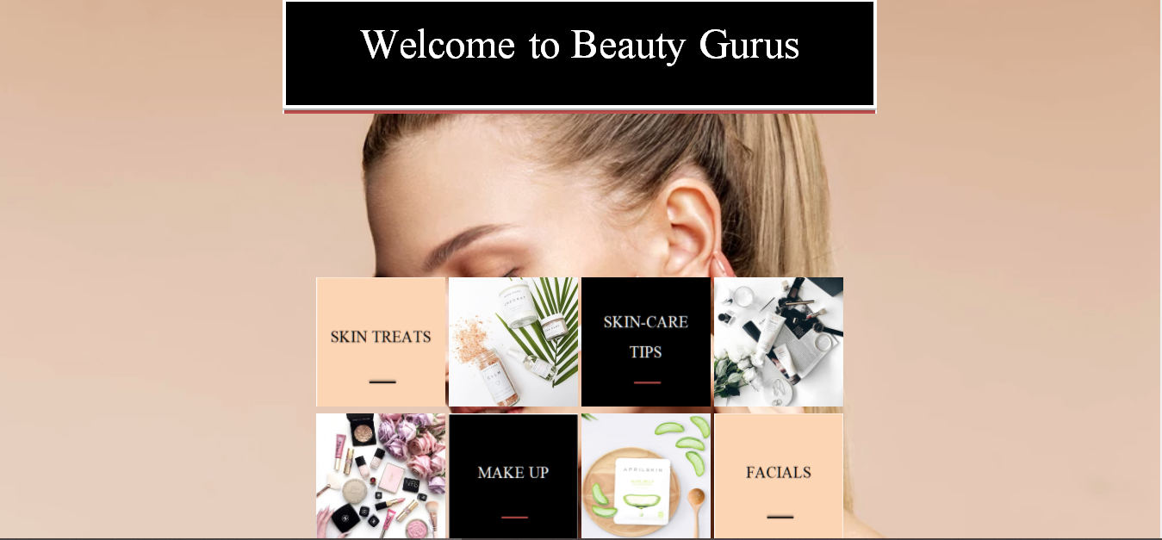

1. Skin-treat page

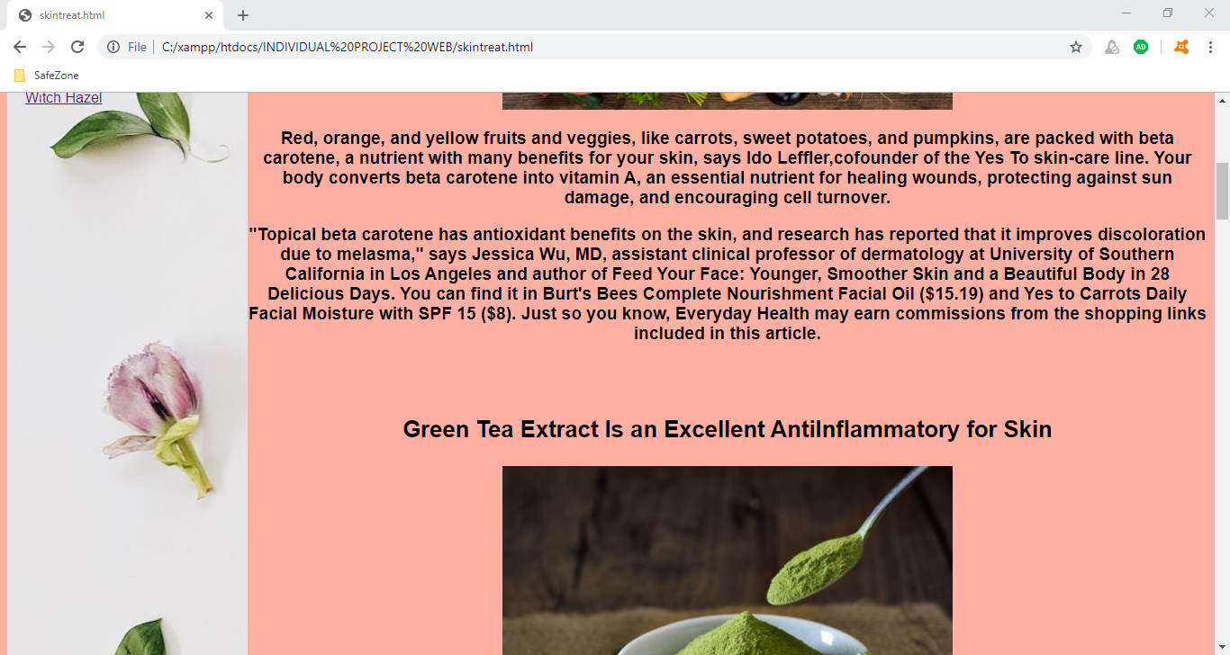

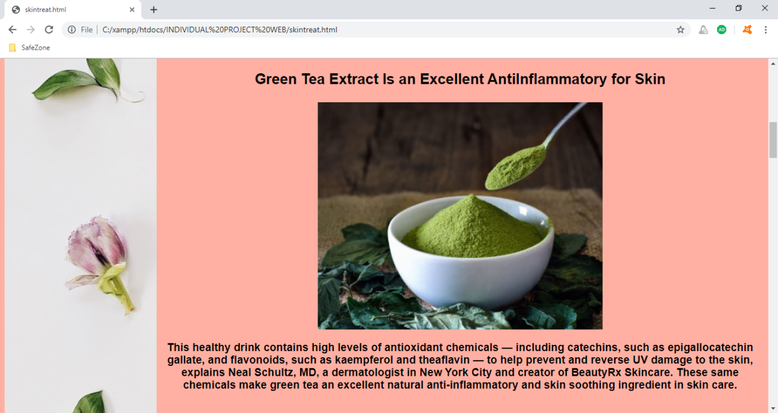

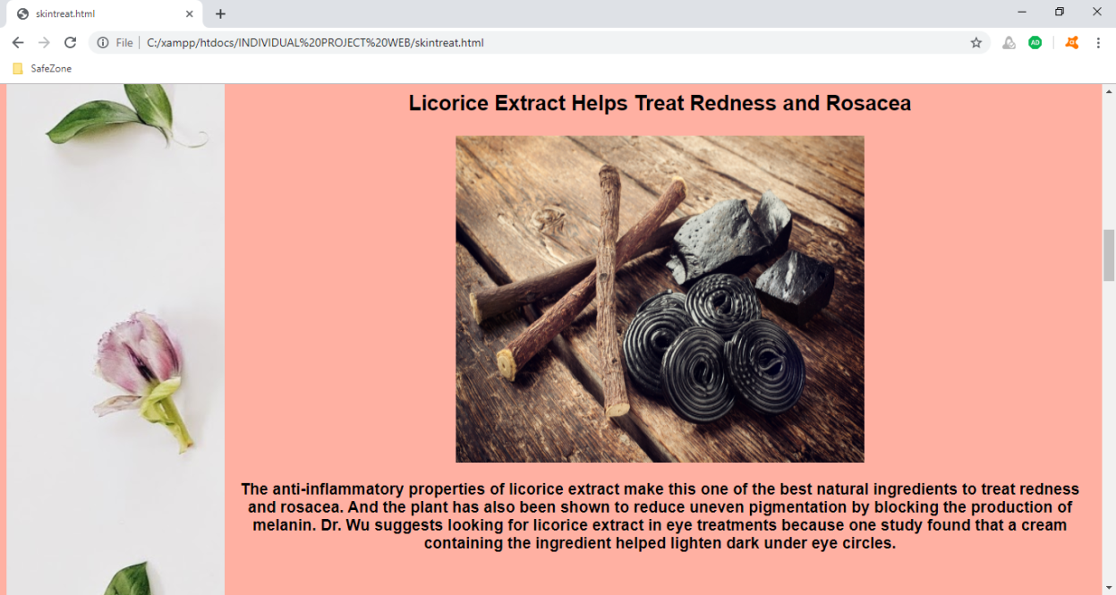

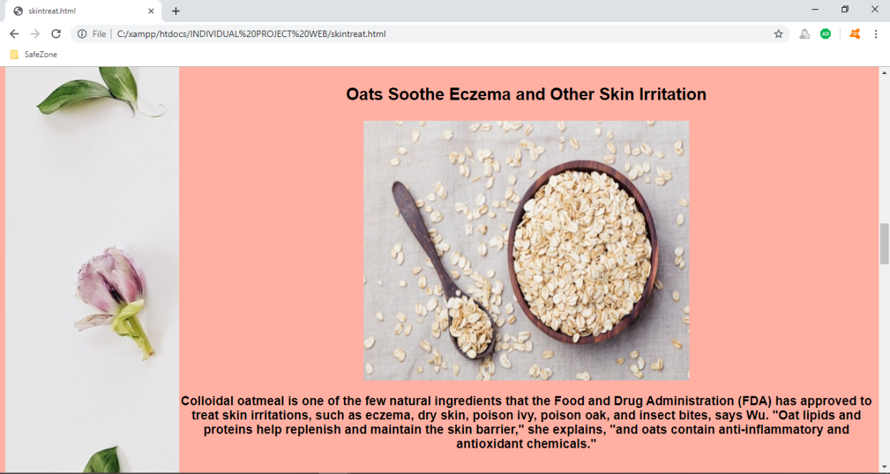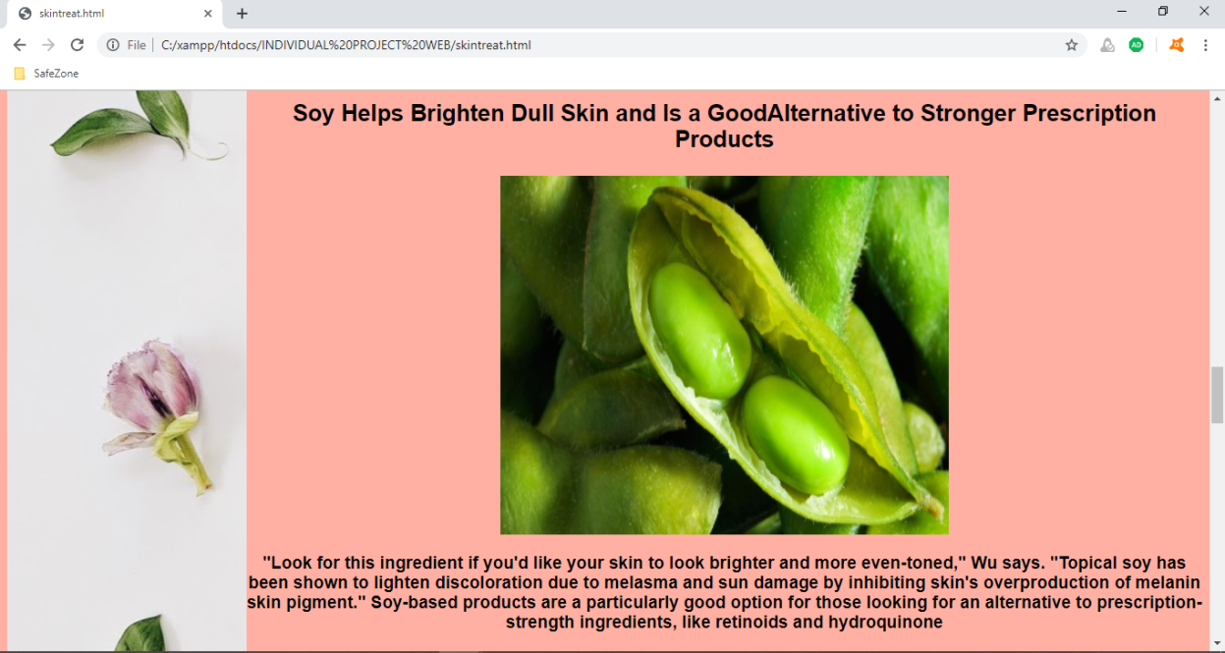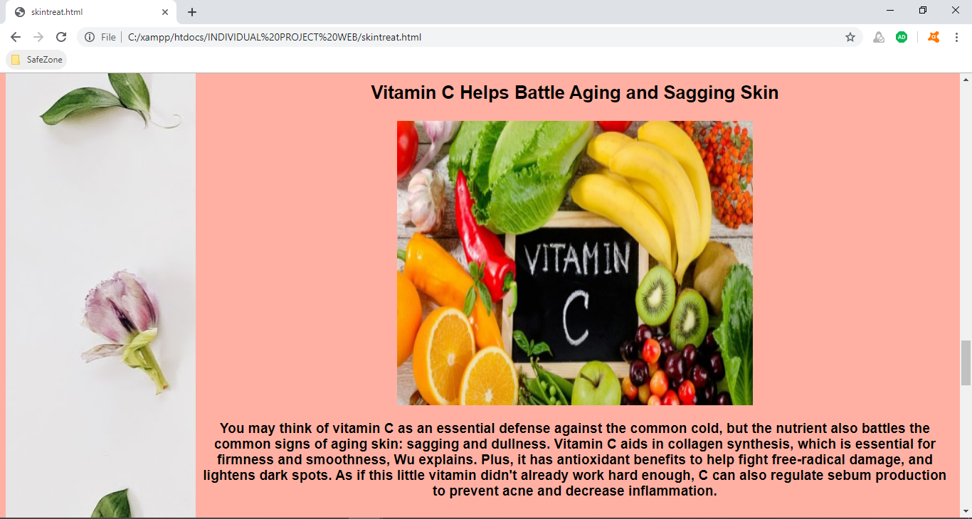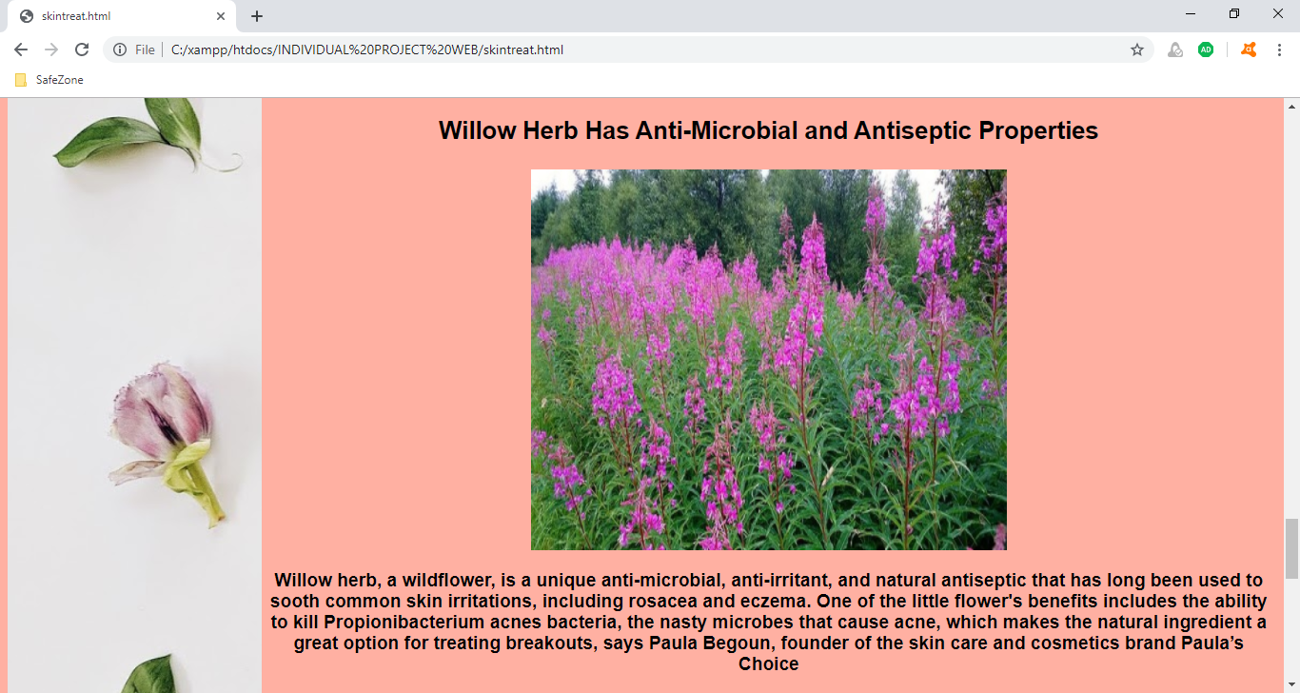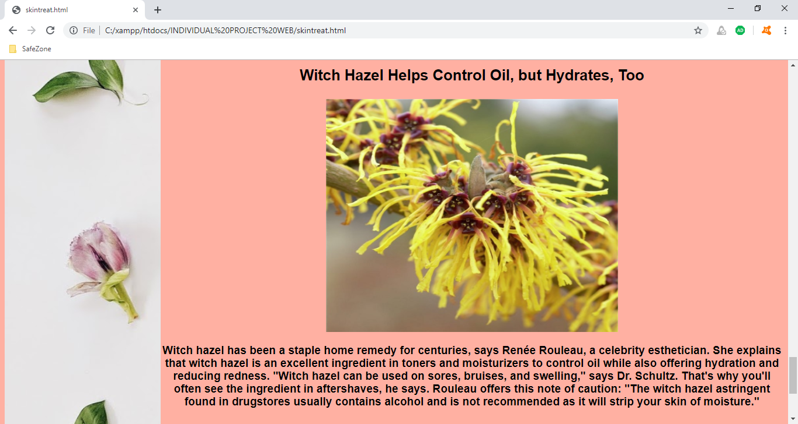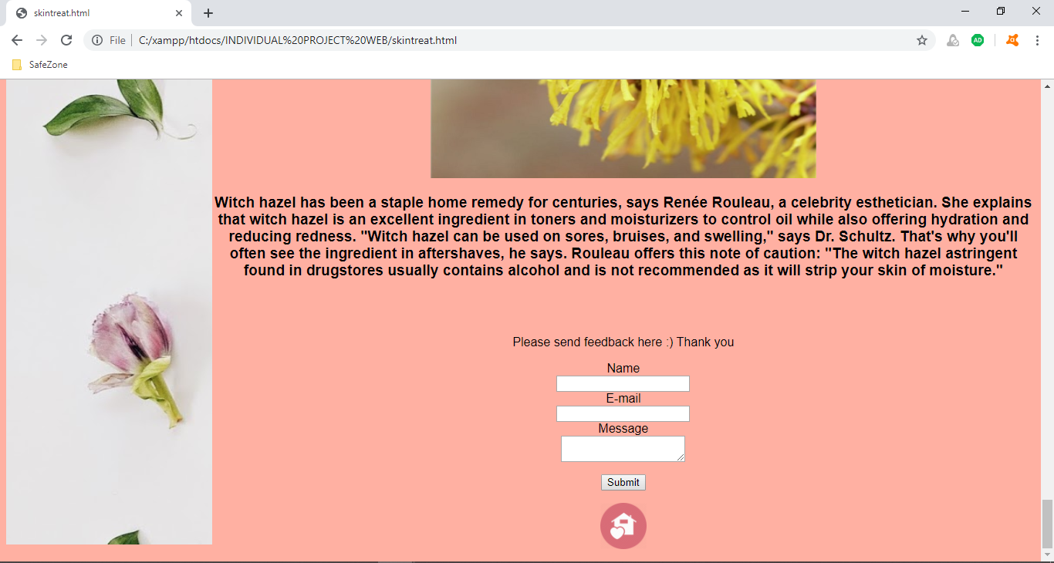

1. Skincare page

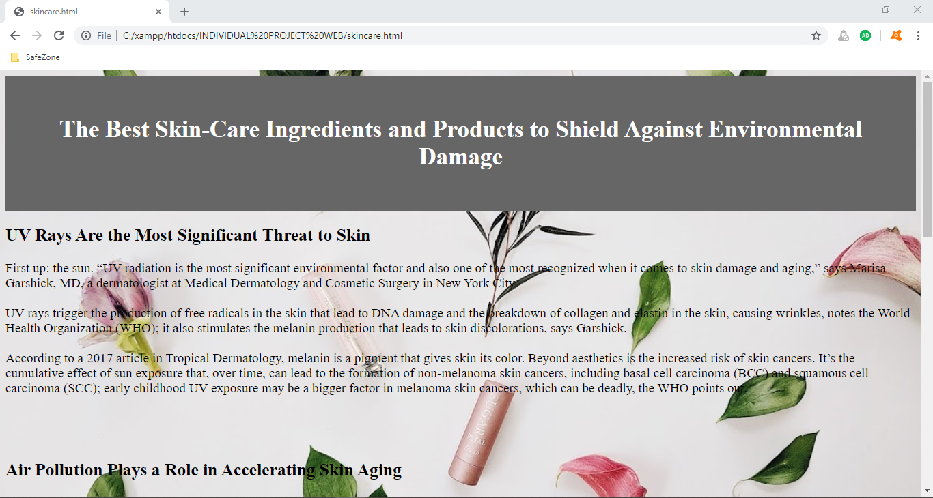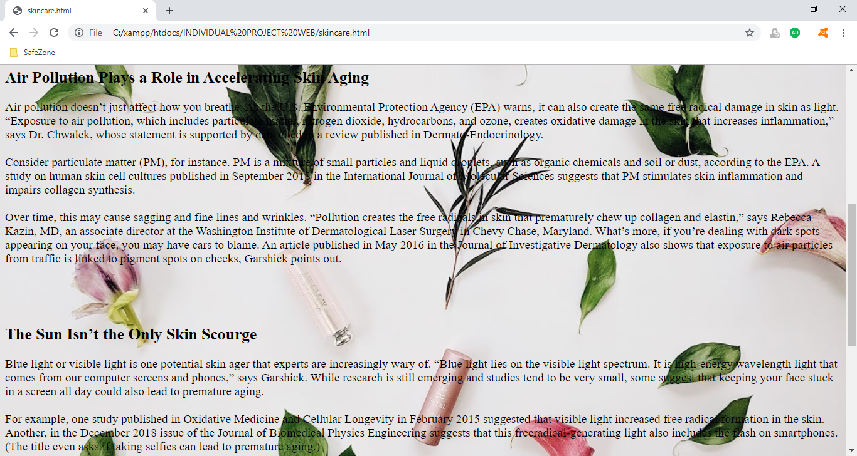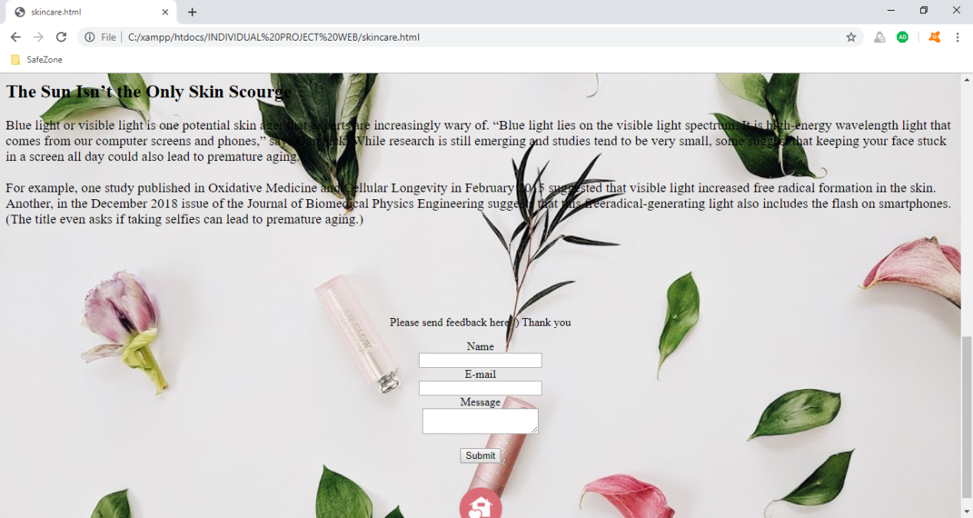

1. Makeup page

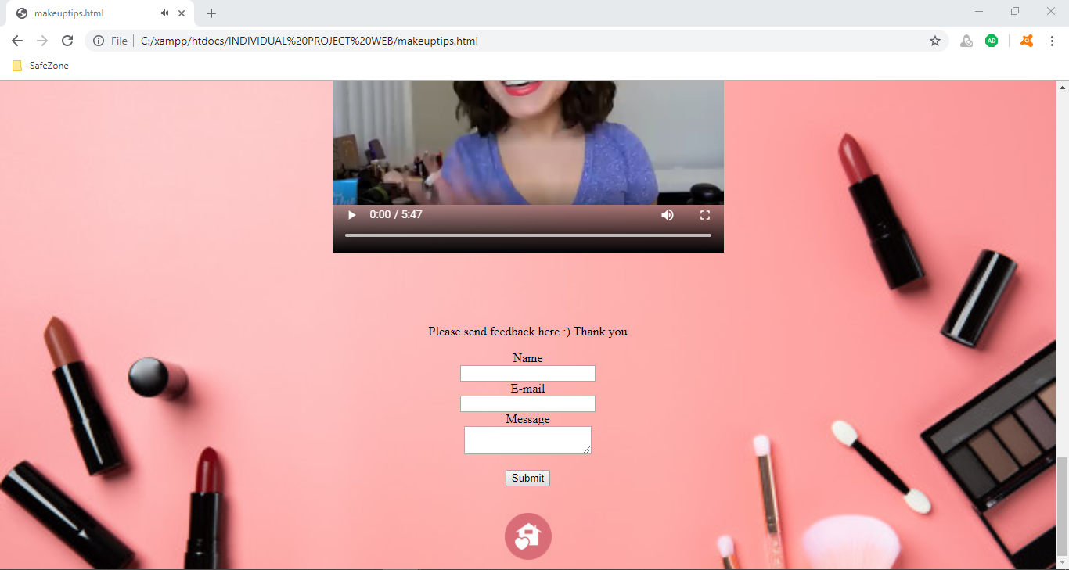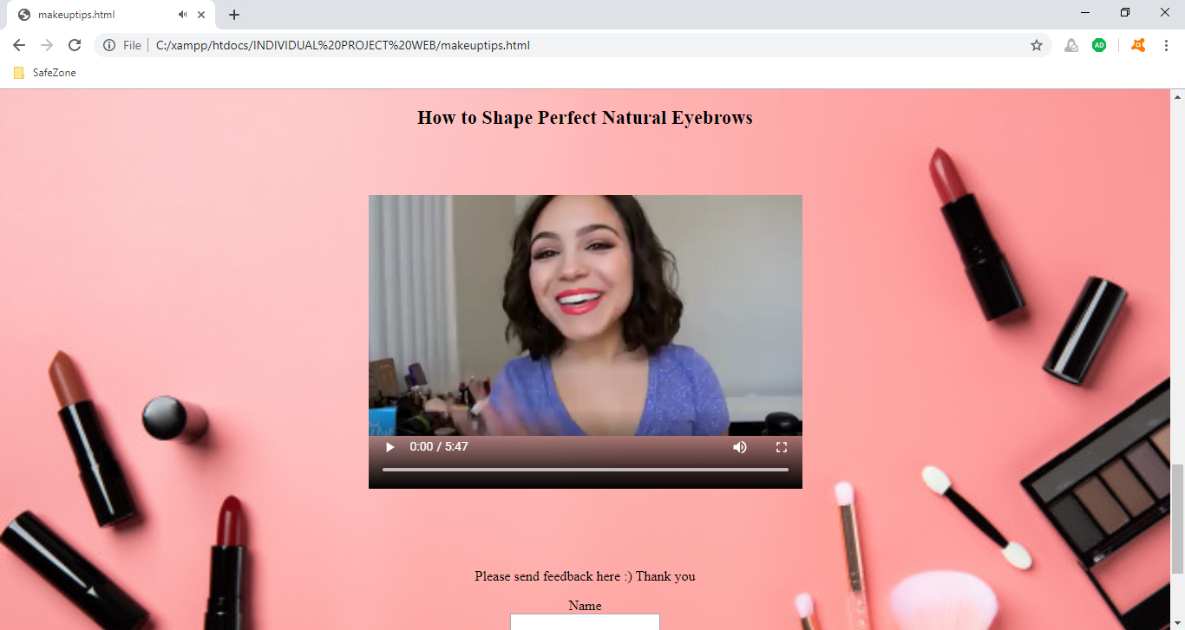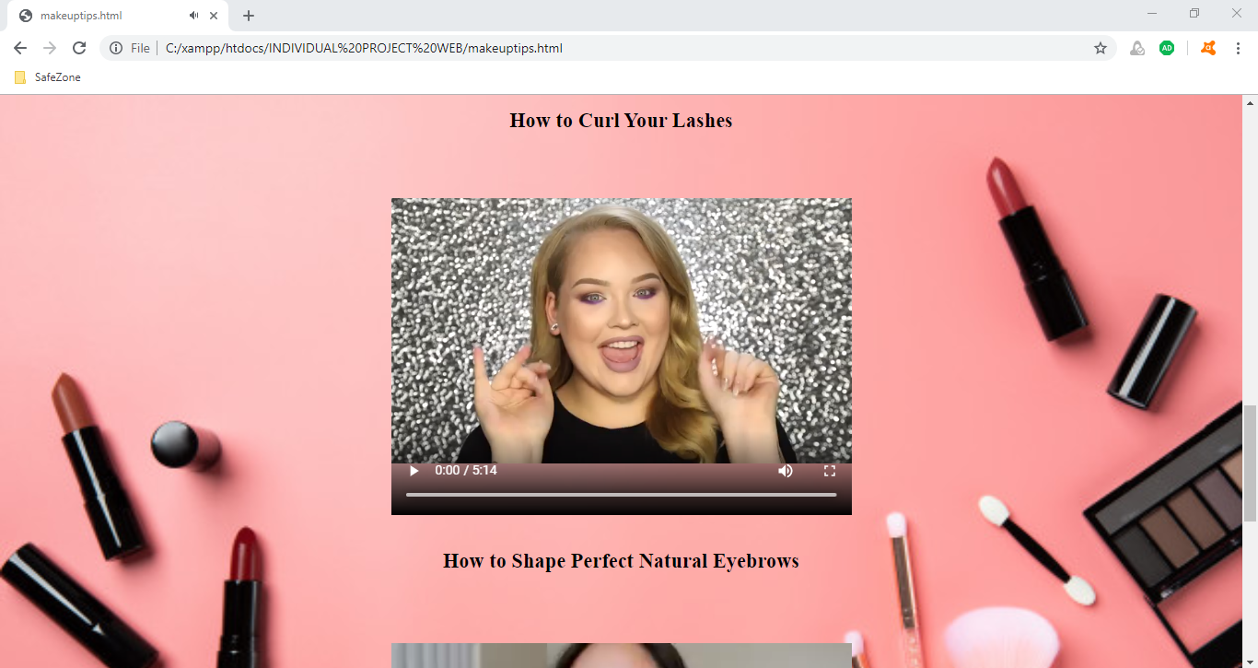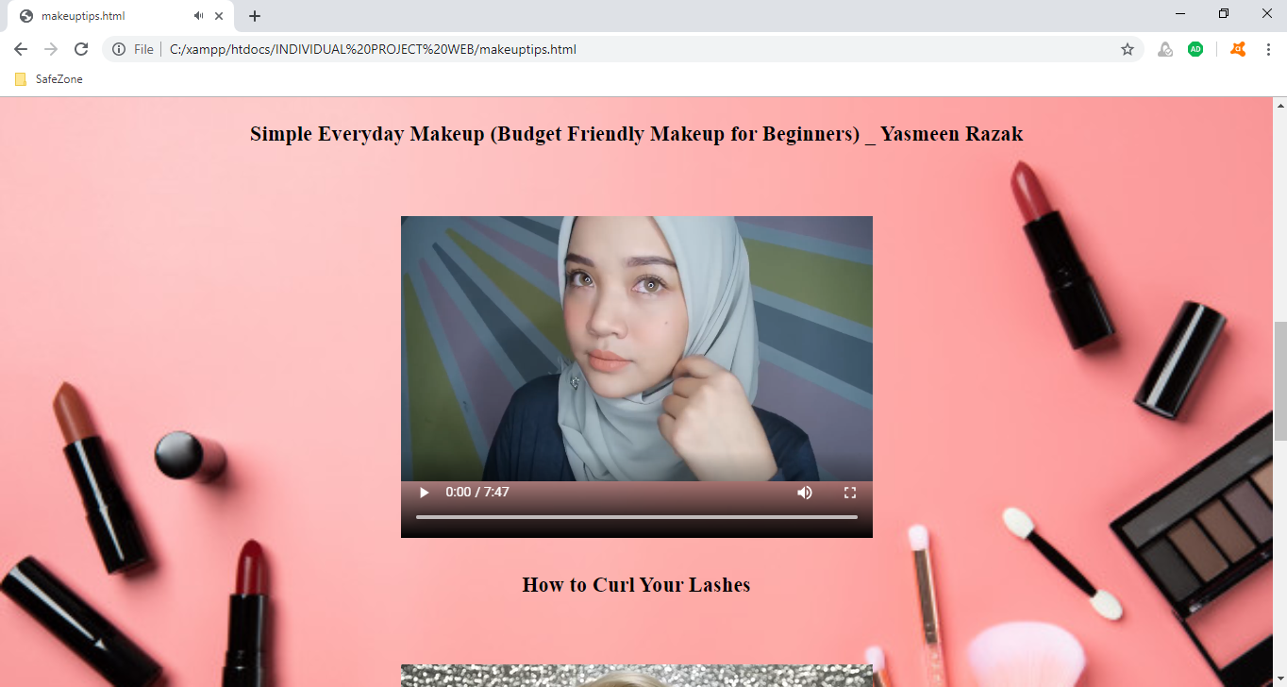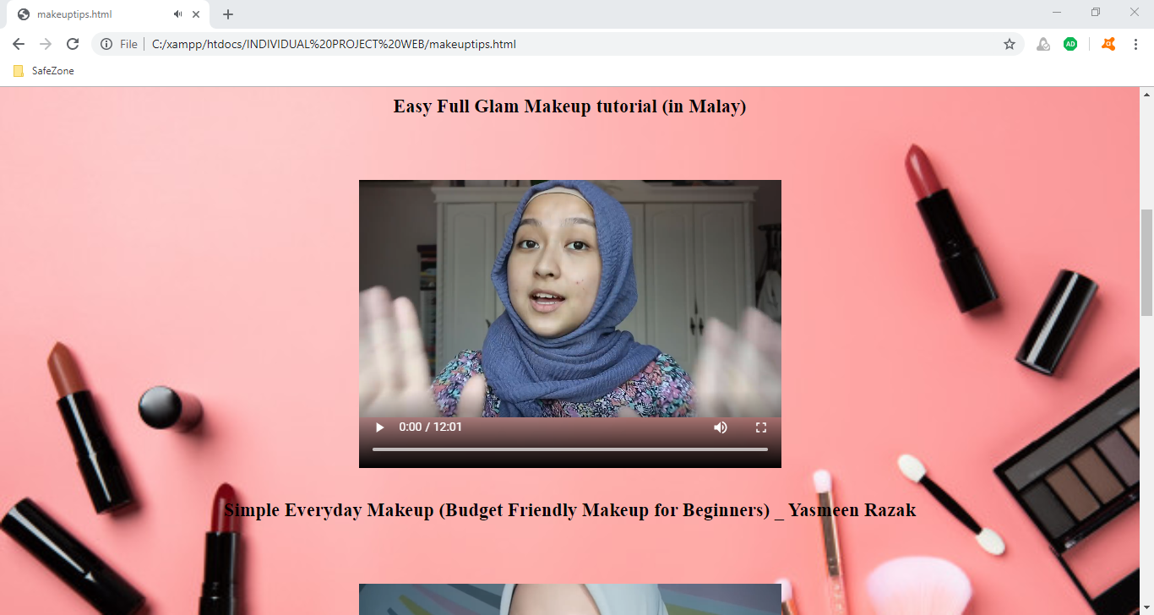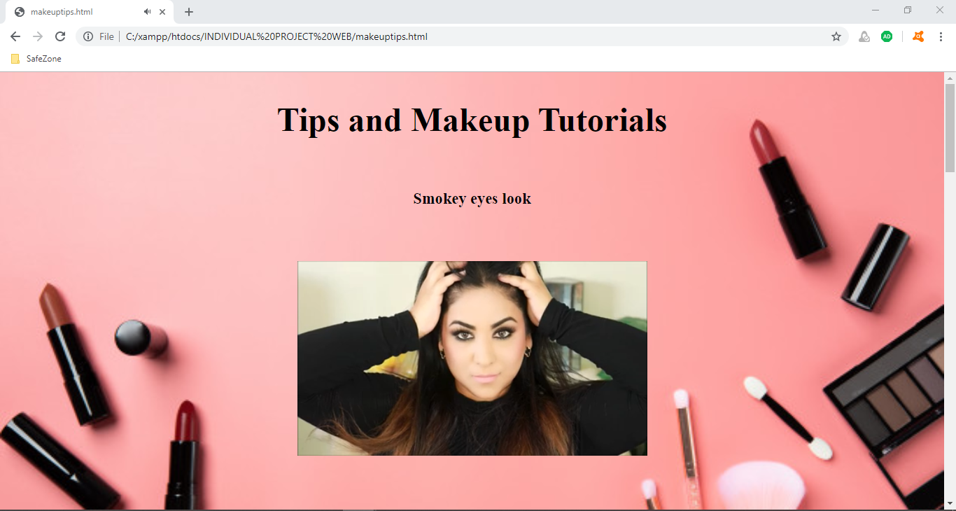

1. Facial page

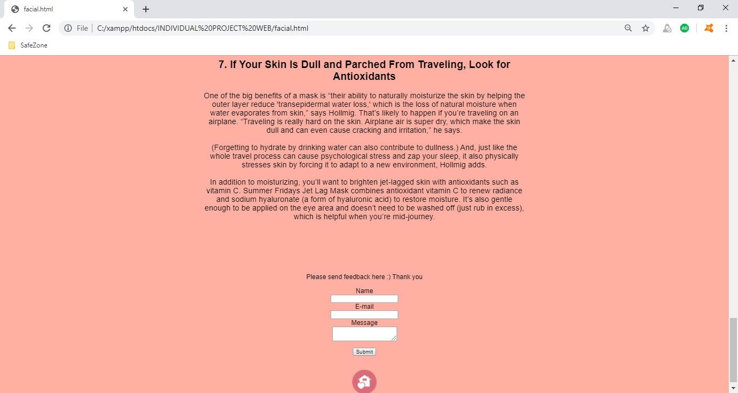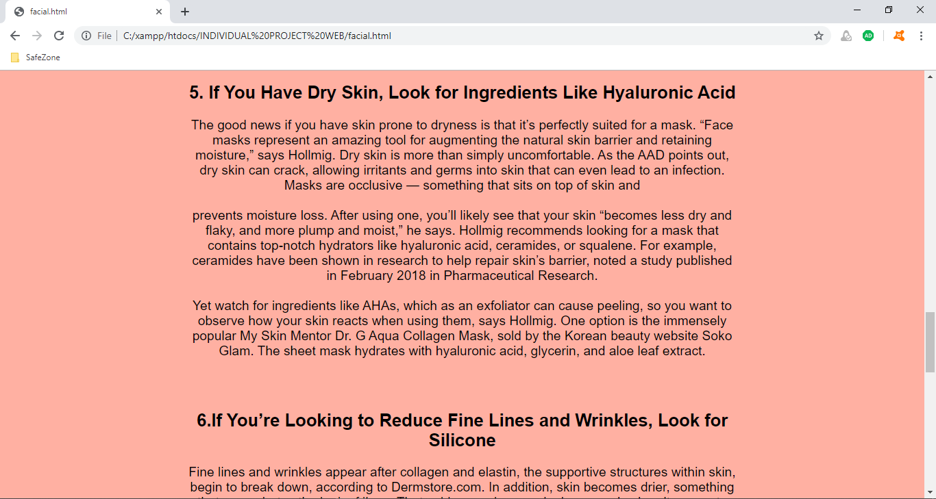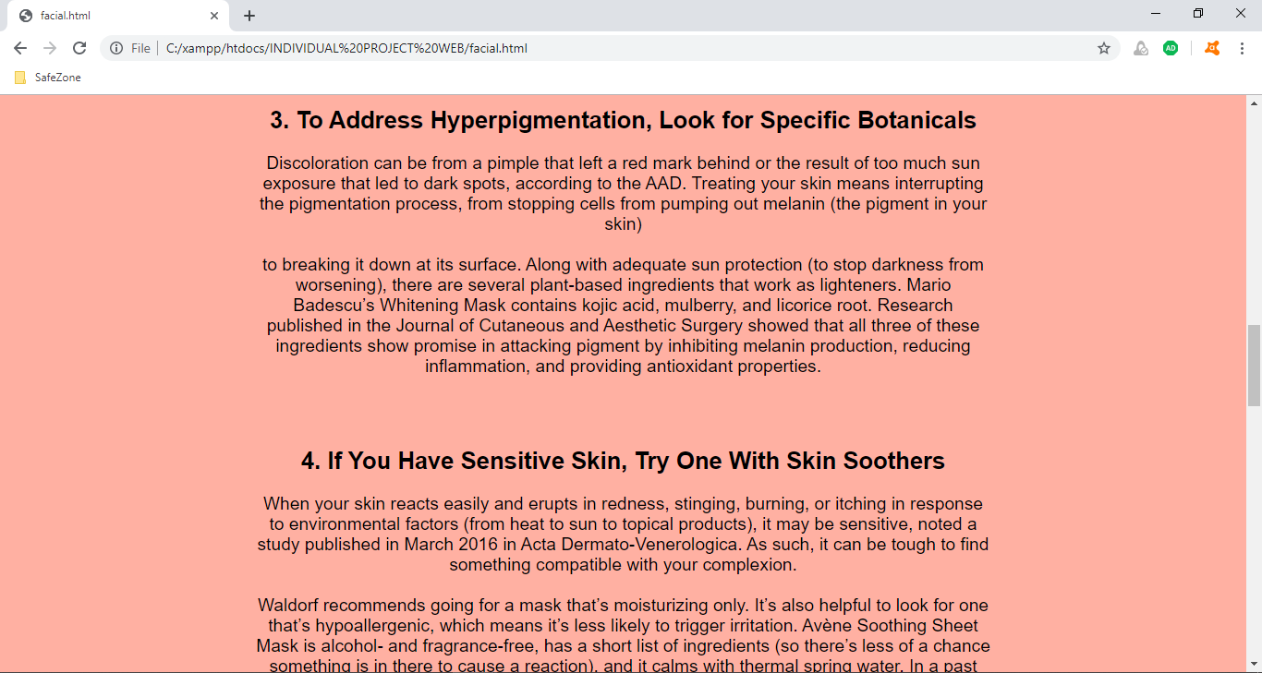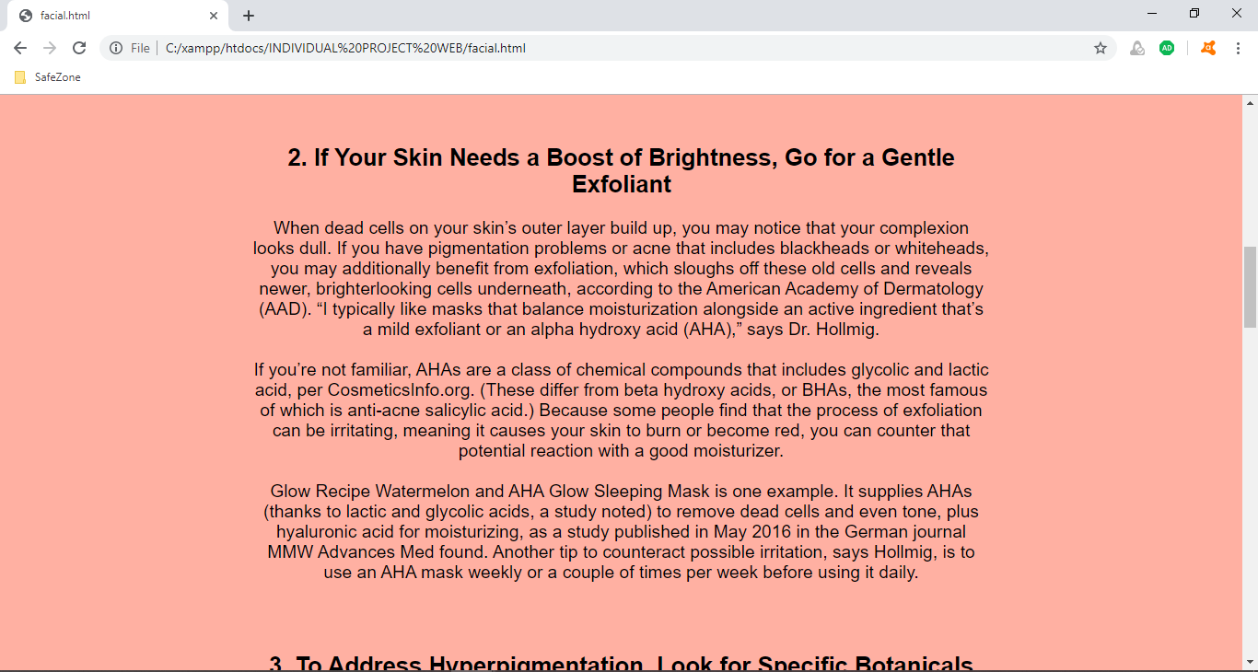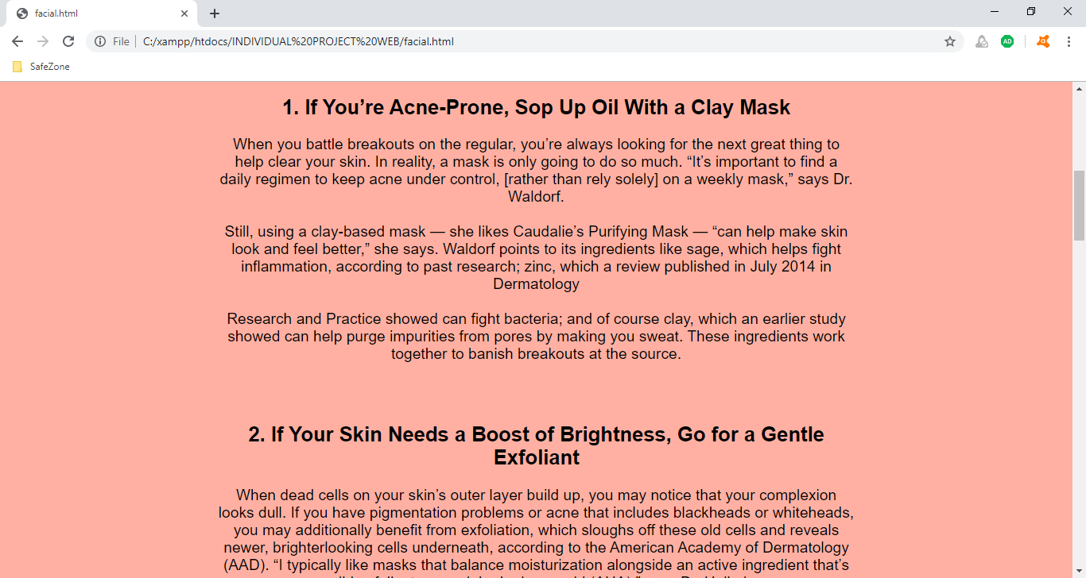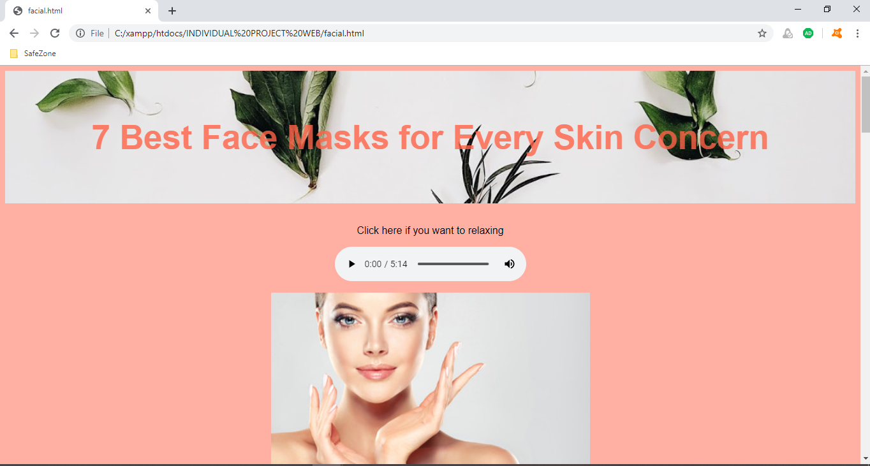

Reference

Link